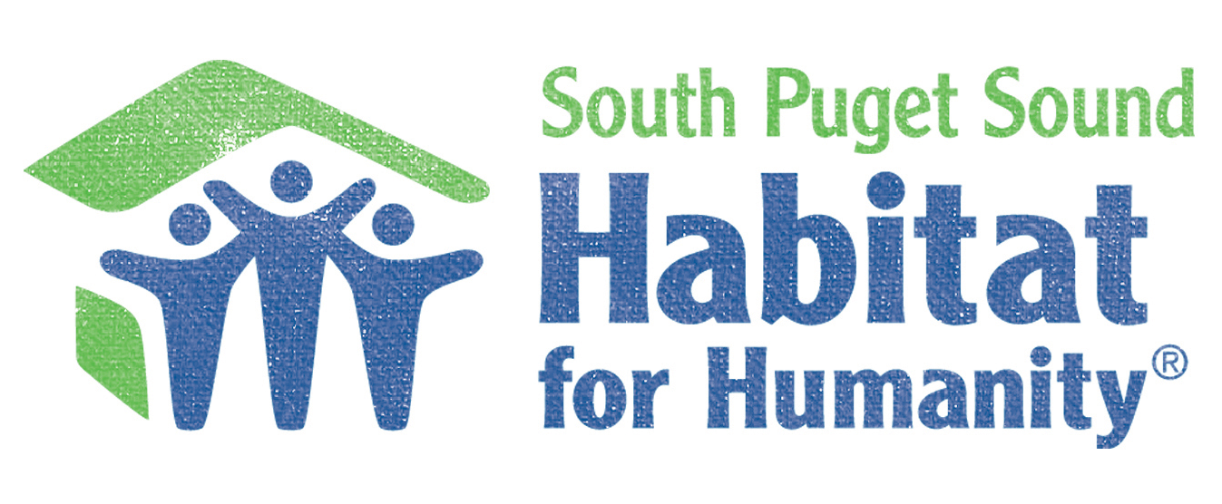

Women Build Partner,
You won’t want to miss the chance to get involved in South Puget Sound Habitat for Humanity’s 2nd annual Women Build!
Join a community of Thurston County leaders, South Sound businesses and nonprofit organizations as we come together to build homes, make an impact, and change lives right here in our community.
What is Women Build? Women Build is a national program with Habitat for Humanity empowering women to get involved by raising awareness about affordable housing while building homes in their communities. We would like to invite the YOU to be a part of South Puget Sound Habitat for Humanity’s five day long build at our Habitat Development, Deyoe Vista in Lacey, WA.
When: Tuesday, May 7th through Saturday, May 11th
Where: Deyoe Vista | 4405 37th Ave SE, Lacey WA
Let us know how YOU want to make a difference, Support Women and Affordable Housing in our community.

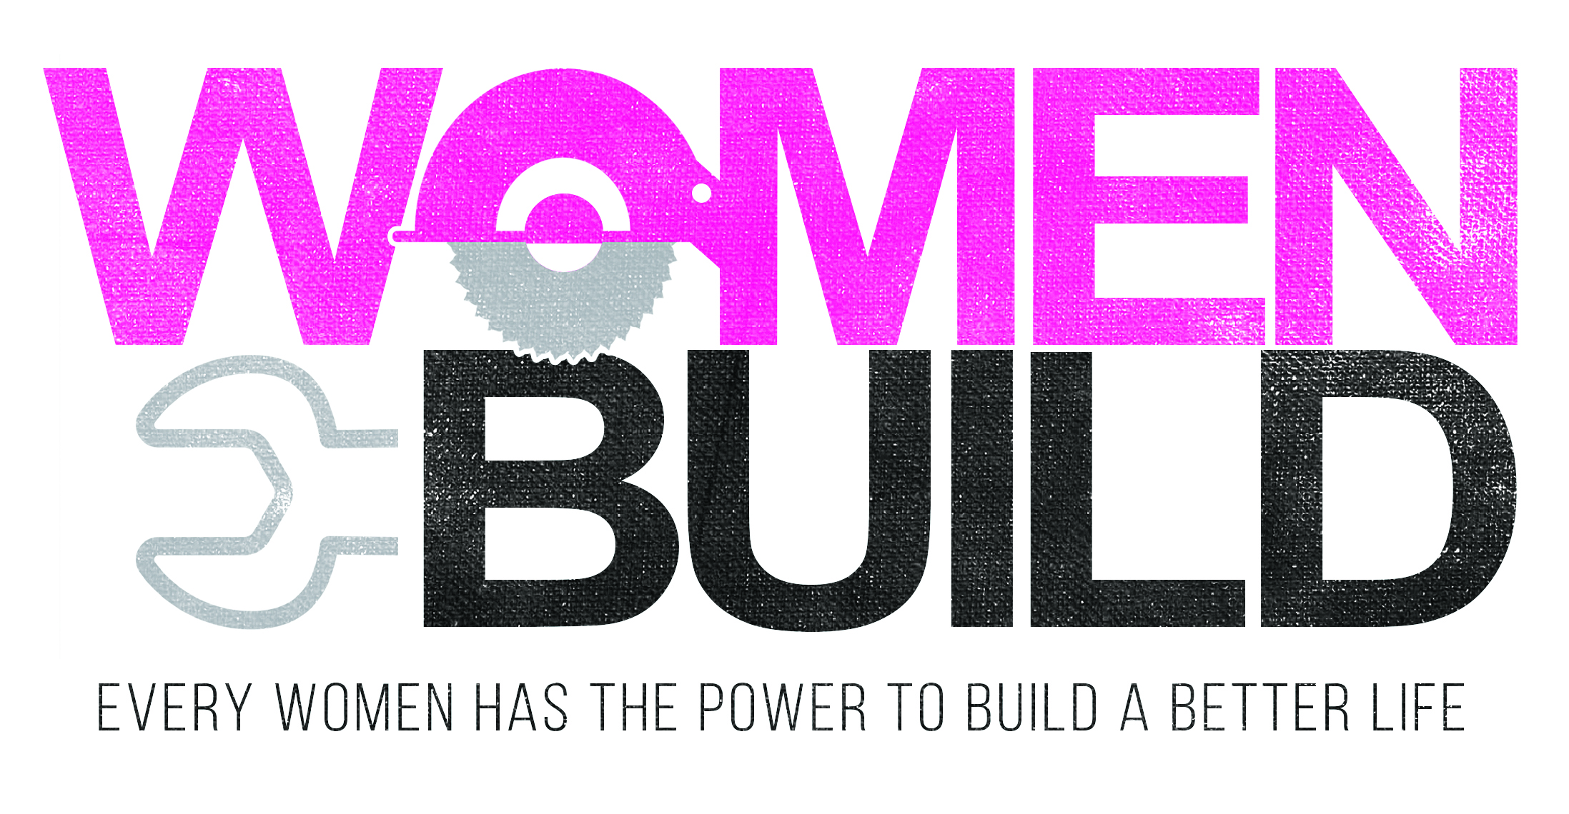

Women Build Title Event Sponsor- $10,000
As the Title event sponsor your company’s name and logo would be featured in prominent placement on our Women Build event T-shirt, on-site event signage and event webpage www.spshabitat.org/womenbuild. Recognition as title event sponsor in all paid promotion of the event (Radio PSA’s, Thurston Talk, etc.). Your organization would have permission to use the Habitat for Humanity logo on your website as a supporter of our organization. Access to our professional event photo online gallery with access to use the photos for marketing purposes.
Title sponsorship also includes a registration for a team of 5 Women Build volunteers (a value of $500) and five tickets to our Women Build celebration to be held at Uncork and Unwind following the close of the week.
Golden Hammer Sponsor -$5,000
As a Golden Hammer sponsor your company’s name and logo would be featured on our Women Build event T-shirt. Your organizations logo would be featured on our event landing page with a hyperlink back to your business or organizations page, and printed onsite signage with other sponsors.
Access to our professional event photo online gallery with access to use the photos for marketing purposes.
Two tickets to our Women Build celebration to be held at Uncork and Unwind following the close of the week.
Silver Hammer Sponsor- $2,000
As a Golden Hammer sponsor your company’s name and logo would be featured on our Women Build event T-shirt. . Your organizations logo would be featured on our event landing page with a hyperlink back to your business or organizations page.
Access to our professional event photo online gallery with access to use the photos for marketing purposes.
Bronze Hammer Sponsor- $1,000
Your organizations logo would be featured on our event landing page with a hyperlink back to your business or organizations page and on site signage during the event.
This sponsorship also includes two tickets to our

Team Builder Sponsor $500
Your organizations logo would be featured on our event landing page with a hyperlink back to your business or organizations page and on site signage during the event.

Lunch Sponsor
For those people who want to help, like to cook, but are incredibly busy, why not provide lunch for our hardworking Women Build volunteers? It doesn't have to be anything fancy, just some nourishing food to keep our volunteers going. We have had lunches from Meconi’s (Subs and Salads), Ramirez Mexican Restaurant, Costco and Chipotle. It can be store bought or homemade. We just ask that you bring enough to feed 25-30 volunteers. Lunch is served around 11:30 am at the Deyoe Vista job site in Lacey located at 4405 37th AVE SE, Lacey WA. If you are able to, stay and visit, our volunteers love to talk about their day.

Lunch providers are responsible for bringing everything they need to prepare and serve their meal
(i.e. plates, napkins, and cutlery)
To reserve your sponsorship or register to help Build contact Shawna Dutton, Director of Development, shawna@spshabitat.org or 360-859-4842
