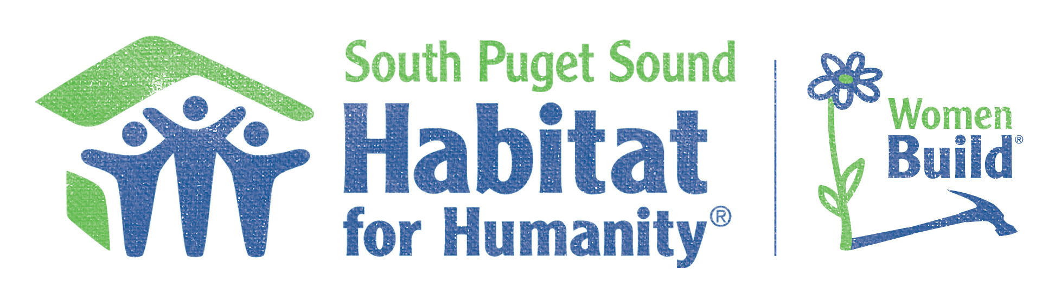
February 2018

WomenBuild Sponsor,

You won’t want to miss the chance to get involved in South Puget Sound Habitat for Humanity’s 1st annual WomenBuild!
Join a community of Thurston County women and South Sound businesses and nonprofit organizations as we come together to build homes, make an impact, and change lives right here in our community. But we can’t do it without your help! What is Women Build? WomenBuild is a national program with Habitat for Humanity empowering women to get involved by raising awareness about affordable housing while building homes in their communities. We would like to invite you to be a part of South Puget Sound Habitat for Humanity’s six day long build at our Habitat Development, Deyoe Vista in Lacey, WA.
When: Monday, May 7th through Saturday, May 12th
Where: Deyoe Vista | 4405 37th Ave SE, Lacey WA
Let us know how YOU want to make a difference, Support Women and Affordable Housing in our community.

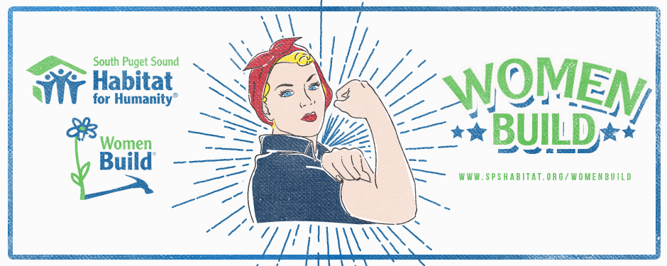

Sponsorship Tiers
WomenBuild Title Event Sponsor- $5,000
As the title event sponsor your company’s name and logo would be featured in prominent placement on our WomenBuild T-shirt, on site event signage and event webpage www.spshabitat.org/get-involved/womenbuild/ Recognition as title event sponsor in all paid promotion of the event. Permission to use SPS Habitat for Humanity logo on your website as a supporter of our organization. Access to professional event photos through online gallery. Recognition of your generous contribution at our Home Dedication Ceremony (to be held at a later date) Title sponsorship also includes a registration for a team of 5 WomenBuild volunteers.
Golden Hammer Sponsor -$2,500
Company logo featured on WomenBuild t-shirt, onsite signage with other sponsors and on our event webpage www.spshabitat.org/get-involved/womenbuild/ Recognition of event sponsorship in paid promotions of the event. Invitation to Home Dedication ceremonies where families will receive the keys to their Habitat Home (to be held at a later date). Company logo featured on swag bag given to all volunteers participating in the event. Access to professional event photos through an online gallery.
Silver Hammer Sponsor- $1,000
Company logo featured on WomenBuild t-shirt, onsite signage with other sponsors and on our event webpage www.spshabitat.org/get-involved/womenbuild/ Access to professional event photos through an online gallery.
Bronze Hammer Sponsor- $500
Company logo featured on WomenBuild t-shirt, onsite signage with other sponsors and on our event webpage www.spshabitat.org/get-involved/womenbuild/.

Team Builder Sponsor $250
Company logo featured onsite signage and with other sponsors on our event webpage www.spshabitat.org/get-involved/womenbuild/.

Women Build Team (5 Volunteers) - $250
Includes participation on one build day of your choosing May 7- May 12th. Each team member will receive a WomenBuild tshirt, lunch and access to an online photo gallery of event photos. Teams that collectively fundraise more than $1,000 will also receive custom pink construction hard hats with their team name and Habitat logo.
Individual Volunteer Ticket - $50
Includes participation on one build day of your choosing May 7- May 12th. A WomenBuild event tshirt, lunch and all the tools as supplies needed for your day of building. Commemorative WomenBuild event photos. *individuals will be scheduled on a first come first serve basis
To reserve your sponsorship or register to volunteer during the event contact Shawna Dutton,
SPS Habitat Development Manager, at shawna@spshabitat.org or 360-859-4842

